# Create Benchmark Strategy Backtest

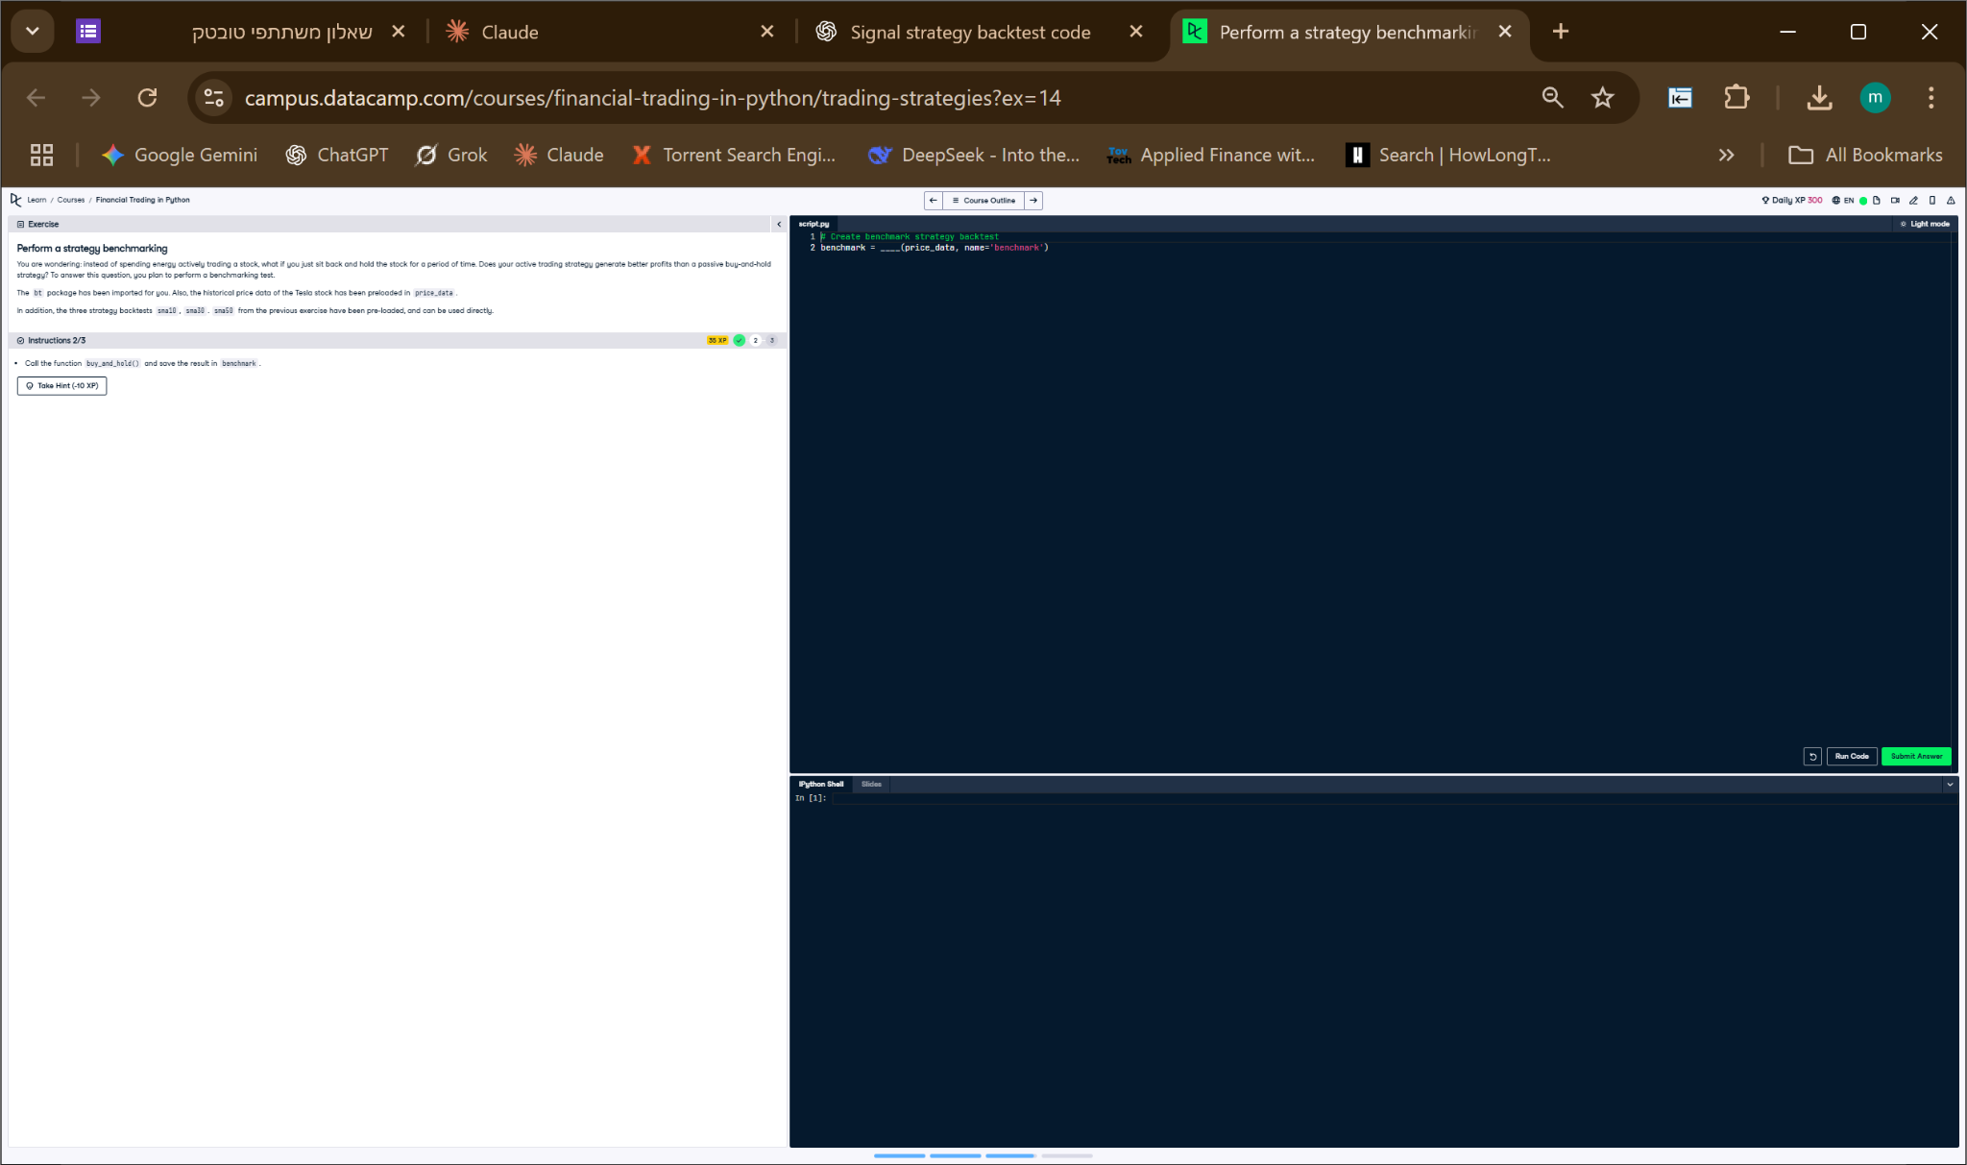

## Python Code

# Create benchmark strategy backtest  
benchmark = buy_and_hold(price_data, name='benchmark')

## Explanation

This code calls the previously defined buy_and_hold() function with the Tesla stock data. It creates a passive investing strategy named 'benchmark', which will be used to compare against other strategies. The result is stored in the variable 'benchmark' as a backtest object.